**DAILY ONLINE ACTIVITIES SUMMARY**

|  |  |  |  |  |  |  |  |  |
| --- | --- | --- | --- | --- | --- | --- | --- | --- |
| **Date:** | **26 May 2020** | | | | | **Name:** | **Sana F Habib** | |
| **Sem & Sec** | **6th sem & B sec** | | | | | **USN:** | **4AL17CS081** | |
| **Online Test Summary** | | | | | | | | |
| **Subject** | | **Computer Graphics and Visualization Test2** | | | | | | |
| **Max. Marks** | | **30** | | **Score** | | | **5** | |
| **Certification Course Summary** | | | | | | | | |
| **Course** | **Career Edge** | | | | | | | |
| **Certificate Provider** | | | **TCS** | | **Duration** | | | **15 days** |
| **Coding Challenges** | | | | | | | | |
| **Status: Executed**  Given an array A of size N where the array elements contain values from 1 to N with duplicates, the task is to find total number of subarrays which start and end with the same element. | | | | | | | | |
| **Uploaded the report in Github** | | | | | **YES** | | | |
| **If yes Repository name** | | | | | [**https://github.com/sanahabib2409199/Sana-F-H.git**](https://github.com/sanahabib2409199/Sana-F-H.git) | | | |
| **Uploaded the report in slack** | | | | | **YES** | | | |
|  | | | | |  | | | |

Online Test Details: (Attach the snapshot and briefly write the report for the same)

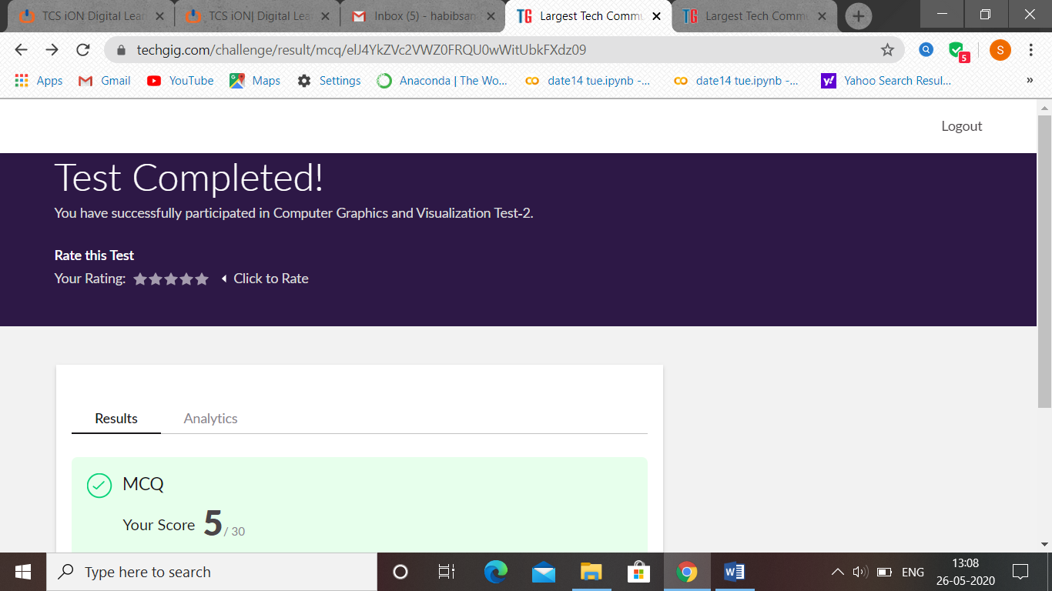

CGV IA test 2 was held today i.e 26 May 2020. Out of 30 marks I scored 5, because of technical issues the answers are not valued. I put tick to answers for each question, I told for sir this issue.

Certification Course Details: (Attach the snapshot and briefly write the report for the same

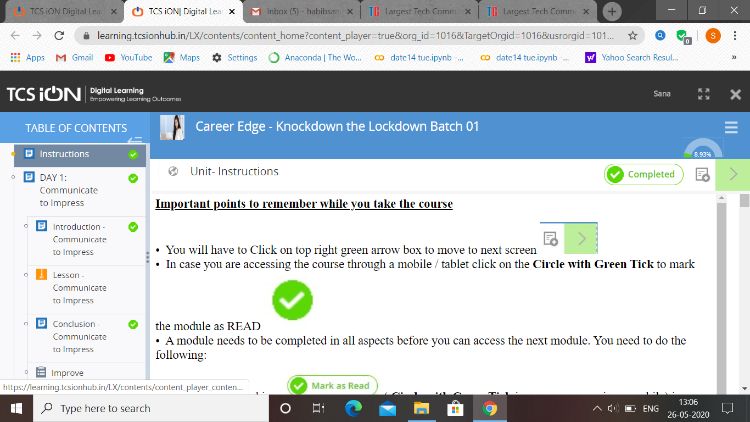

(26-05-2020)-TCS –Career Edge.

Coding Challenges Details: (Attach the snapshot and briefly write the report for the same)

Program 